Date:22/01/2026
Demonstrate virtualization by Installing Type-2 Hypervisor in your device, create and configure VM image with a Host Operating system (Either Windows/Linux) using virtual box.

AIM
To demonstrate virtualization by installing a Type-2 Hypervisor (Oracle VirtualBox) and creating a Virtual Machine with a Guest Operating System (Ubuntu Linux).
SOFTWARE USED
- Host Operating System: Windows 10 / Windows 11
- Virtualization Software: Oracle VirtualBox (Type-2 Hypervisor)
- Guest Operating System: Ubuntu 22.04 LTS

PROCEDURE
- Oracle VirtualBox was installed on the host operating system.
- Ubuntu Linux ISO file was downloaded for use as the guest OS.
- A new virtual machine was created in VirtualBox.
- Linux was selected as the operating system type and Ubuntu as the version.
- Required RAM was allocated to the virtual machine.
- A virtual hard disk was created with sufficient storage space.
- The Ubuntu ISO file was attached to the virtual machine.
- The virtual machine was started and Ubuntu installation was initiated.
- User details and system settings were configured during installation.
- The installation was completed and Ubuntu OS was successfully launched inside the virtual machine.

Output

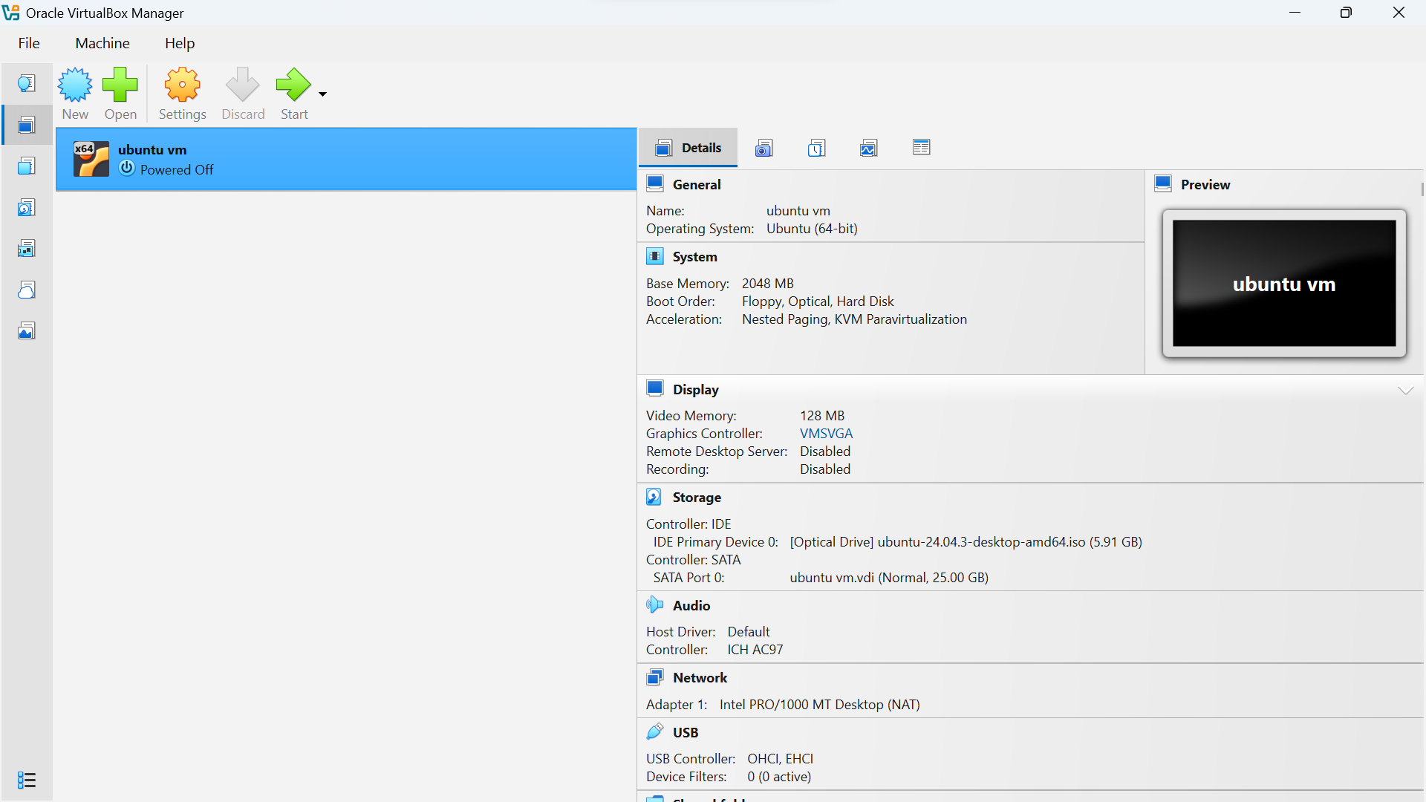

RESULT
The virtualization process was successfully implemented using Oracle VirtualBox. A virtual machine was created and Ubuntu Linux was installed successfully as the guest operating system. The virtual environment functioned properly, demonstrating the working of a Type-2 hypervisor.

